Project-2

Sahithi Nallani , Juveria , Hampi and Srihitha

Front-end

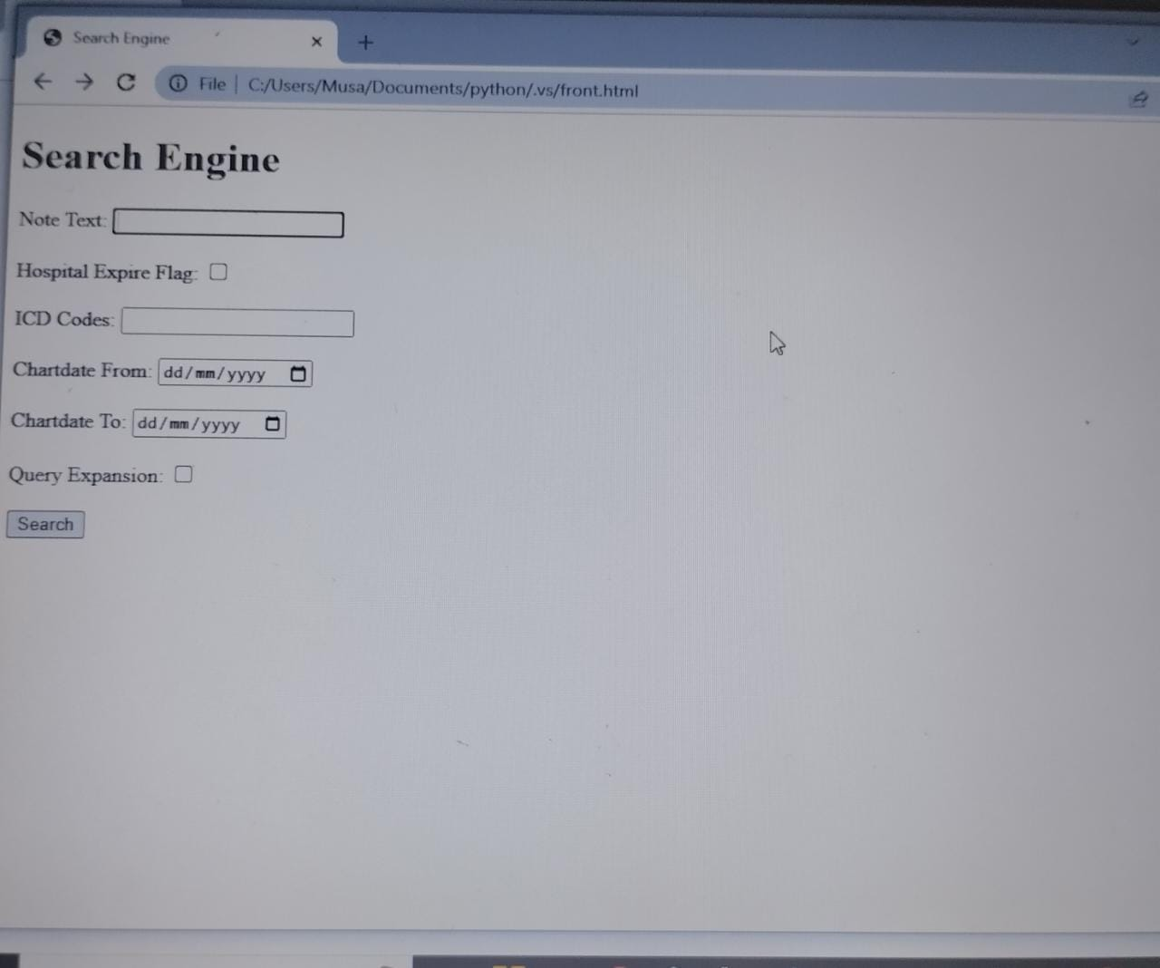

Extracting data set

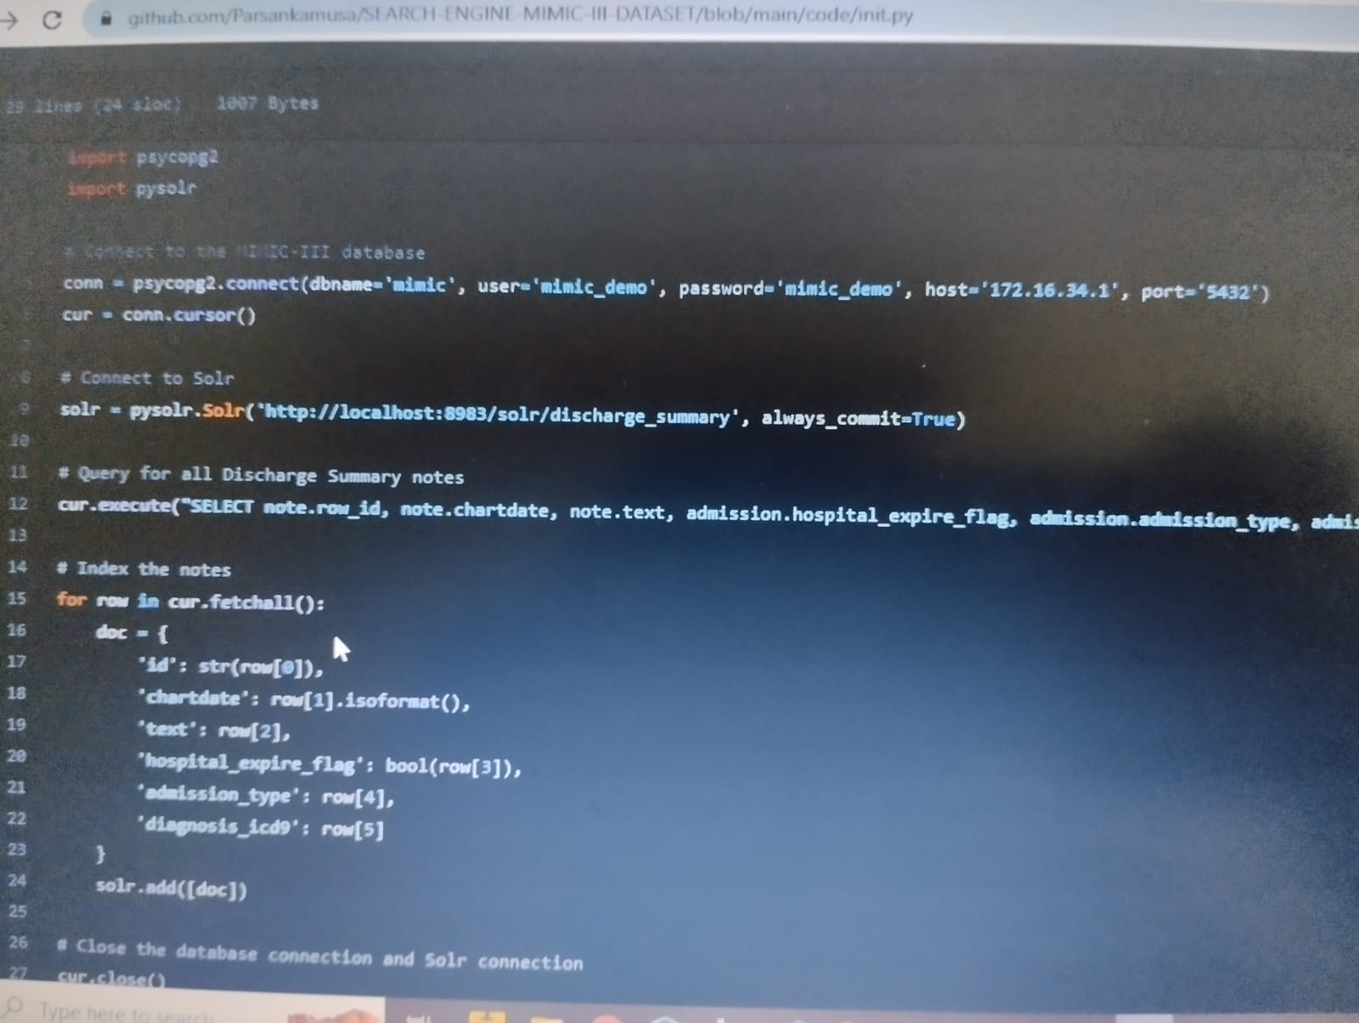

**Output:**

1. **Car crash in note text and hospital_expire_flag= 0 for the associated hospital admission:**

1. **Car crash in note text:**

**3.Note chartdate is between 2110-01-01 AND 2120-01-01:**

**4.Brain cancer and its synonyms from CHV in note text:**

**Schema fields:**

